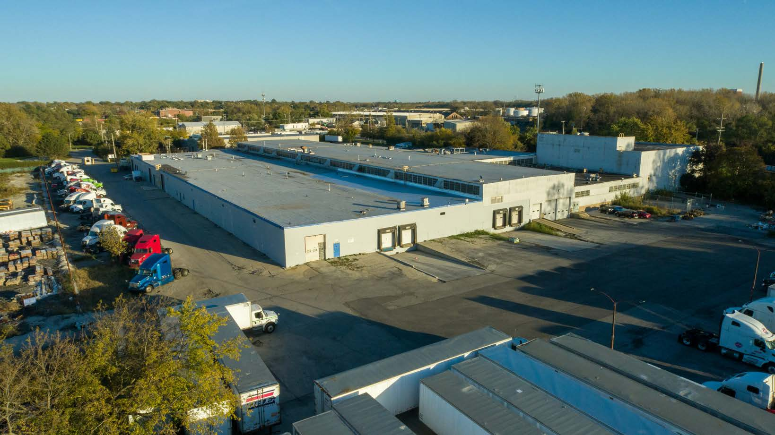

**Chicago, IL (February 2025)** - Entre Commercial Realty is pleased to announce that Chris Wilbur and Jeff Locascio, SIOR represented the landlord in leasing two units, totaling 63,115 SF, at 3500 W 127th St in Blue Island, IL. The 32,250 SF unit was leased to a local furniture distribution company that will be using the warehouse to store inventory for three retail locations. This unit was vacant for less than a week. The 30,865 SF unit was leased by an existing tenant that is expanding within the building to support continued growth. Chris Wilbur and Jeff Locascio, SIOR were the sole brokers in these transactions.

***About Entre Commercial Realty LLC***

Entre Commercial Realty LLC is a full-service commercial real estate firm based in suburban Chicago, IL. Entre provides a wide range of real estate services including brokerage, property management, and construction throughout the Midwest and nationally through its affiliates.

For more information visit **www.entrecommercial.com**

The information contained herein is from sources deemed reliable but is submitted subject to errors, omissions and to change of price or terms without notice.

**www.entrecommercial.com**

3550 Salt Creek Lane, Suite 104, Arlington Heights, IL. 60005



**PRESS RELEASE**

**Entre Commercial Realty Completes Two Leases**

**Totaling 63,115 SF in Blue Island, IL**

3550 Salt Creek Lane, Suite 104

Arlington Heights, IL 60005

847.310.4295

www.entrecommercial.com