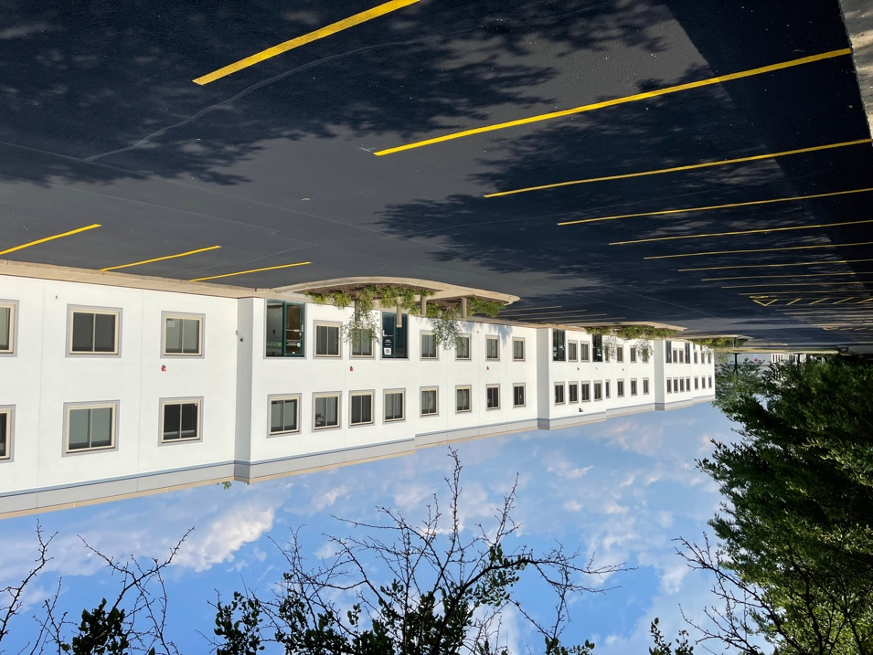

Elisabeth Lazzara, Mike DeSerto, and Cory Kay of Entre Commercial Realty represented the Purchaser in this transaction. Dawn Koenigseder of Berkshire Hathaway Starck Real Estate represented the Seller.

***About Entre Commercial Realty LLC***

Entre Commercial Realty LLC is a full-service industrial/commercial real estate firm based in suburban Chicago, IL. Entre provides a wide range of real estate services including brokerage, property management, and construction throughout the metro-Chicago area and nationally through its affiliates.

For more information visit **www.entrecommercial.com**

**Chicago, IL (April 2024) -** Entre Commercial Realty announces the completed sale of a 42,901 SF building located at 2503 Spring Ridge Road in Spring Grove, IL. This rare free-standing two-story industrial facility boasts 18-foot clear height, 1 dock, 8 drive-in doors, and ample parking. The purchaser, KBI Custom Case, intends to renovate both the office and warehouse areas while utilizing half of the facility as their new headquarters.

KBI Custom Case, a Woman-Owned casework manufacturer, has been providing the Midwest with high-quality millwork for over 25 years. Specializing in the design and manufacturing of premium-grade casework for the commercial sector, KBI Custom Case brings extensive expertise and experience to their craft.

**Entre Completes 42,901 SF Sale in Spring Grove**

The information contained herein is from sources deemed reliable but is submitted subject to errors, omissions and to change of price or terms without notice.

**www.entrecommercial.com**

3550 Salt Creek Lane, Suite 104, Arlington Heights, IL. 60005



**PRESS RELEASE**

3550 Salt Creek Lane, Suite 104

Arlington Heights, IL 60005

847.310.4295

www.entrecommercial.com